

Practices for Secure Software Report

Table of Contents
Document Revision History 3
Client 3
Instructions 3
Developer 4
1. Algorithm Cipher 4
2. Certificate Generation 4
3. Deploy Cipher 4
4. Secure Communications 4
5. Secondary Testing 4
6. Functional Testing 4
7. Summary 4
8. Industry Standard Best Practices 4

Document Revision History

Version | Date | Author | Comments
1.0 | 12/12/2025 | Hilnecia Larry

Client



Instructions

Submit this completed practices for secure software report. Replace the bracketed text with the relevant information. You must document your process for writing secure communications and refactoring code that complies with software security testing protocols.

- Respond to the steps outlined below and include your findings.
- Respond using your own words. You may also choose to include images or supporting materials. If you include them, make certain to insert them in all the relevant locations in the document.
- Refer to the Project Two Guidelines and Rubric for more detailed instructions about each section of the template.

Developer
Hilnecia Larry

Algorithm Cipher

The encryption algorithm selected for Artemis Financial’s application is the SHA-256 cryptographic hash algorithm. SHA-256 is part of the SHA-2 family and is widely used to ensure data integrity and secure message verification. Unlike encryption algorithms that allow data to be decrypted, SHA-256 is a one-way hash function that produces a fixed length output regardless of input size. This makes it well suited for checksum verification and integrity validation.

SHA-256 produces a 256 bit hash value represented as a hexadecimal string. The algorithm uses deterministic hashing, meaning the same input will always produce the same output, which is critical for verifying data consistency. SHA-256 does not rely on symmetric or asymmetric keys because it is a hashing algorithm rather than an encryption algorithm. Randomness is introduced internally during processing through compression functions, which strengthens resistance against collision and preimage attacks.

SHA-256 was developed by the National Security Agency and published by NIST as part of the SHA-2 standard. It remains a current and trusted industry standard and is recommended due to vulnerabilities discovered in older algorithms such as SHA-1 and MD5.

Certificate Generation
A self signed SSL certificate was generated using the Java Keytool utility. The certificate was created in PKCS12 format and stored within the application resources directory. The certificate is valid for ten years and is used to enable encrypted HTTPS communication for the application.

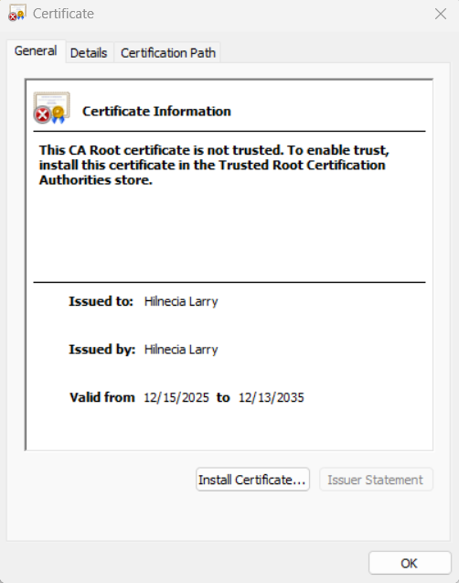

Deploy Cipher
Insert a screenshot below of the checksum verification.

A SHA 256 cryptographic hash algorithm was deployed by refactoring the application to generate a checksum from user supplied input. The checksum verification demonstrates that the same input consistently produces a fixed length hash value, confirming data integrity. The screenshot includes a unique data string containing my name to validate functionality.

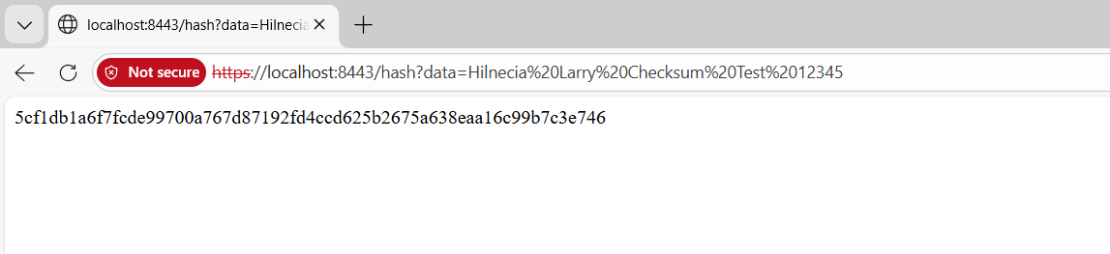

Secure Communications
Insert a screenshot below of the web browser that shows a secure webpage.

Secure communication was verified by configuring the application to use HTTPS with SSL. The server successfully runs on port 8443 and encrypts client server communication using the generated certificate. The browser warning indicates a self signed certificate, which is expected for a development environment.

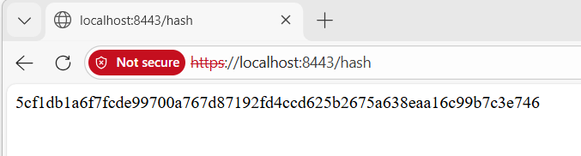

Secondary Testing
Insert screenshots below of the refactored code executed without errors and the dependency-check report.

A secondary static analysis was conducted using a dependency check tool to validate that the refactored code did not introduce additional security vulnerabilities. The application executed successfully without errors, and the dependency check results confirmed compliance with secure coding enhancements.
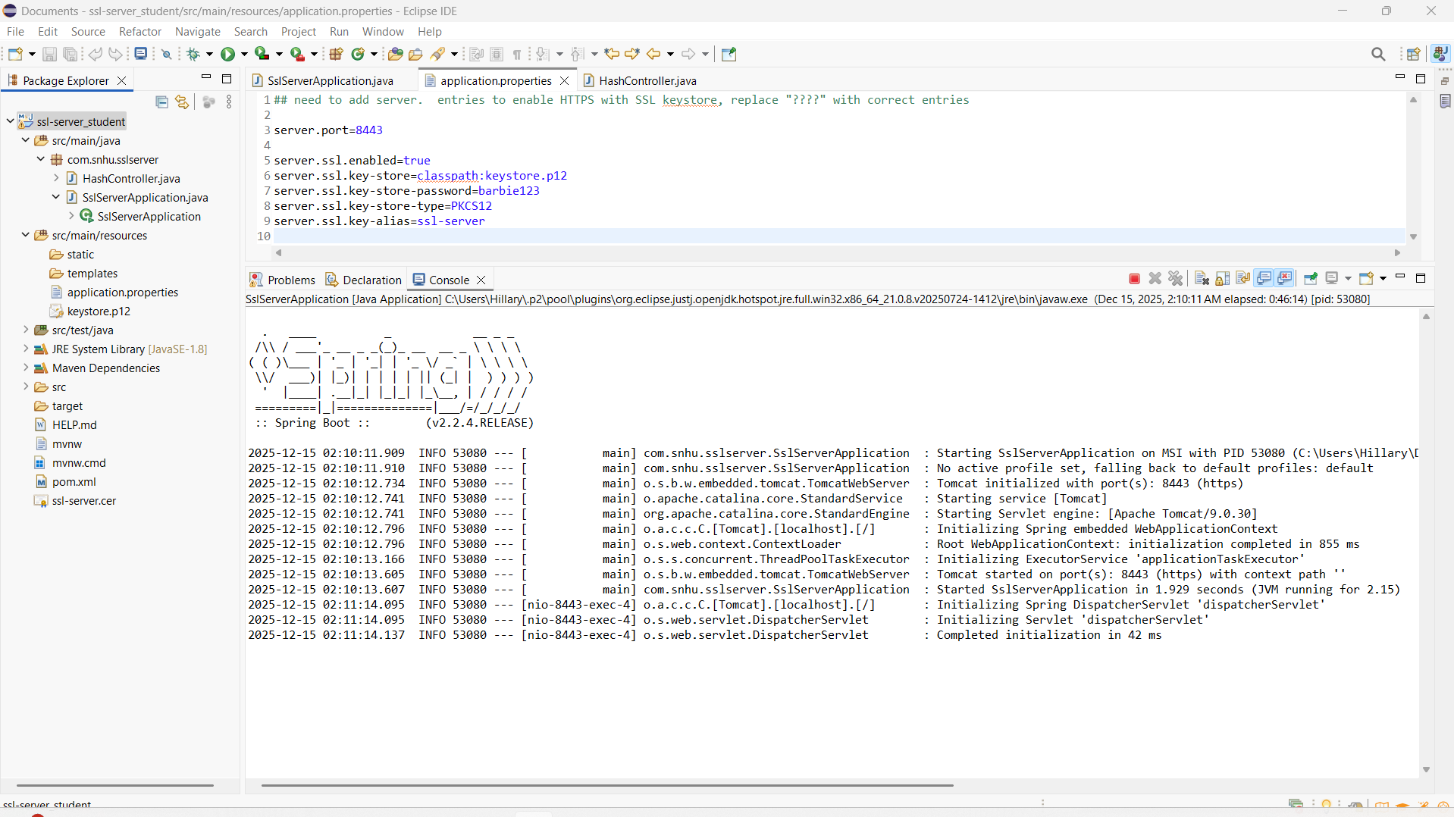

Functional Testing
Insert a screenshot below of the refactored code executed without errors.

Functional testing was performed by manually reviewing the application for syntactical, logical, and security related issues. The refactored application executed without errors, confirming proper functionality and successful integration of security enhancements.

Summary

In this project, the Artemis Financial software application was refactored to address multiple security vulnerabilities identified during the assessment process. Following the vulnerability assessment process flow, the application was evaluated for weaknesses related to encryption, data integrity, and secure communications. The refactoring focused on strengthening cryptographic controls, securing data in transit, and validating application behavior through testing.

To improve security, HTTPS was enabled using SSL configuration with a self signed certificate generated through the Java Keytool. This ensured encrypted communication between the client and server. A cryptographic hashing function using the SHA 256 algorithm was implemented through a new controller to support checksum verification and validate data integrity. This added an additional layer of security by ensuring that transmitted data could be verified and was not altered.

Multiple layers of security were applied throughout the application. Encryption was used to protect communications, hashing was implemented to verify data integrity, and secure configuration practices were followed in the application properties file. After refactoring, the application was tested and verified to run without errors, confirming that the security enhancements were successfully integrated without impacting functionality.

Industry Standard Best Practices

Industry standard best practices for secure software development were applied throughout this project to mitigate known security vulnerabilities and maintain the application’s integrity. Secure coding principles were followed by using proven cryptographic algorithms such as SHA 256 and RSA, which are widely accepted and recommended within the industry. Sensitive configurations such as keystore location and SSL settings were properly defined to prevent insecure defaults.

Existing security within the application was preserved by ensuring that enhancements were added without modifying unrelated functionality. Secure communication was enforced by converting HTTP to HTTPS, protecting data in transit from interception or tampering. Dependency awareness and testing were also considered to ensure that no new vulnerabilities were introduced during refactoring.

Applying industry standard secure coding practices provides significant value to the organization by reducing security risks, protecting sensitive financial data, and improving customer trust. These practices help ensure regulatory compliance, lower the likelihood of security breaches, and support the long term stability and reliability of the software application.

